1. Perform Binary Classification in this data set. 65% of prediction accuracy is quite decent.

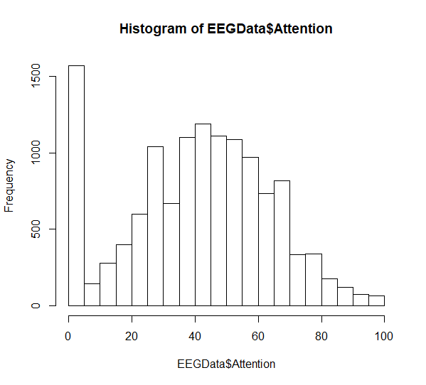

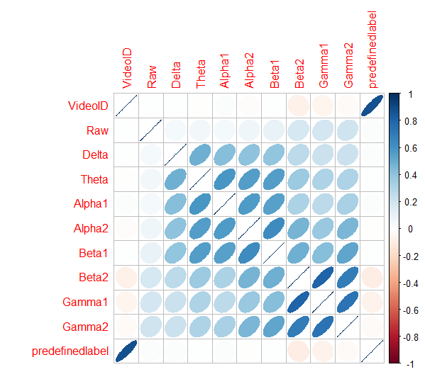

> logistic<- glm(Attention~VideoID+Mediation+Raw+Delta+Theta+Alpha1+Alpha2+Beta1+Beta2+Gamma1+Gamma2+predefinedlabel+user.definedlabeln, data = train_proj)

> summary(logistic)

Call:

glm(formula = Attention ~ VideoID + Mediation + Raw + Delta +

Theta + Alpha1 + Alpha2 + Beta1 + Beta2 + Gamma1 + Gamma2 +

predefinedlabel + user.definedlabeln, data = train_proj)

Deviance Residuals:

Min 1Q Median 3Q Max

-54.732 -13.007 -1.616 11.799 75.756

Coefficients:

Estimate Std. Error t value Pr(>|t|)

(Intercept) 2.326e+01 6.143e-01 37.856 < 2e-16 ***

VideoID -1.453e+00 1.246e-01 -11.663 < 2e-16 ***

Mediation 5.721e-01 8.501e-03 67.302 < 2e-16 ***

Raw -4.534e-04 2.762e-04 -1.642 0.100678

Delta -3.578e-06 3.483e-07 -10.272 < 2e-16 ***

Theta -3.768e-06 1.070e-06 -3.523 0.000429 ***

Alpha1 -2.620e-05 3.577e-06 -7.325 2.56e-13 ***

Alpha2 -2.921e-05 4.727e-06 -6.180 6.67e-10 ***

Beta1 2.986e-05 6.775e-06 4.407 1.06e-05 ***

Beta2 5.344e-06 4.367e-06 1.224 0.221065

Gamma1 -1.875e-05 4.086e-06 -4.590 4.48e-06 ***

Gamma2 -3.857e-06 7.707e-06 -0.501 0.616705

predefinedlabel 6.694e+00 7.292e-01 9.181 < 2e-16 ***

user.definedlabeln -2.953e+00 3.653e-01 -8.084 6.97e-16 ***

---

Signif. codes: 0 ‘***’ 0.001 ‘**’ 0.01 ‘*’ 0.05 ‘.’ 0.1 ‘ ’ 1

(Dispersion parameter for gaussian family taken to be 324.7618)

Null deviance: 5925067 on 10248 degrees of freedom

Residual deviance: 3323937 on 10235 degrees of freedom

AIC: 88372

Number of Fisher Scoring iterations: 2

**Features highlighted in pink colour have linear correlation with Attention**

> logistic1<- glm(Attention~VideoID+Mediation+Raw+Delta+Theta+Alpha1+Alpha2+Beta1+Beta2+Gamma1+Gamma2+predefinedlabel+user.definedlabeln, data = test_proj)

> summary(logistic1)

Call:

glm(formula = Attention ~ VideoID + Mediation + Raw + Delta +

Theta + Alpha1 + Alpha2 + Beta1 + Beta2 + Gamma1 + Gamma2 +

predefinedlabel + user.definedlabeln, data = test_proj)

Deviance Residuals:

Min 1Q Median 3Q Max

-70.54 -12.31 -0.98 10.59 60.82

Coefficients:

Estimate Std. Error t value Pr(>|t|)

(Intercept) 4.824e+01 1.420e+00 33.977 < 2e-16 ***

VideoID -2.606e-01 2.497e-01 -1.044 0.296780

Mediation 4.002e-02 2.169e-02 1.845 0.065092 .

Raw -1.618e-03 1.840e-03 -0.880 0.379131

Delta -1.388e-06 5.890e-07 -2.356 0.018539 *

Theta -1.785e-05 1.818e-06 -9.817 < 2e-16 ***

Alpha1 -2.231e-05 5.764e-06 -3.871 0.000111 ***

Alpha2 -4.488e-05 7.887e-06 -5.691 1.41e-08 ***

Beta1 3.178e-06 1.475e-05 0.215 0.829452

Beta2 8.248e-05 7.257e-06 11.366 < 2e-16 ***

Gamma1 3.764e-05 1.560e-05 2.413 0.015898 *

Gamma2 2.562e-04 3.441e-05 7.446 1.31e-13 ***

predefinedlabel -2.087e+00 1.464e+00 -1.426 0.154073

user.definedlabeln -5.919e+00 7.335e-01 -8.069 1.08e-15 ***

---

Signif. codes: 0 ‘***’ 0.001 ‘**’ 0.01 ‘*’ 0.05 ‘.’ 0.1 ‘ ’ 1

(Dispersion parameter for gaussian family taken to be 305.4749)

Null deviance: 928323 on 2561 degrees of freedom

Residual deviance: 778350 on 2548 degrees of freedom

(1 observation deleted due to missingness)

AIC: 21946

Number of Fisher Scoring iterations: 2

**Logistic Regression (Accuracy) Residual deviance ~77.8%**

1. Find Precision
2. Find Recall
3. generate ROC Curve

b. Random forest

1. Find the accuracy using Random forest method.
2. Find the best accuracy among Logistic regression and Random forest method.